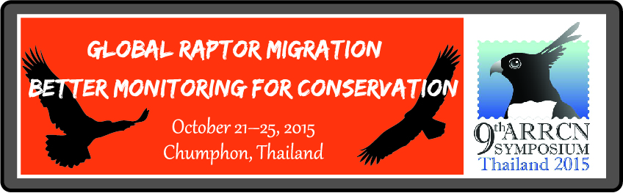
Registration Form
Date: 21-25 October 2015
Early bird registration 150 USD
Approximate 6 months ahead (deadline April 30th, 2015)
Regular registration 175 USD
Approximate 4 months ahead (deadline June 30th, 2015)
Late registration 220 USD
Within 1 month before symposium (deadline September 30th, 2015)
* Registration fee includes the attendance and packages of the conference, all meals, two banquets local transportation in Chumphon province and field trip. It does NOT include accommodation and transportation from Bangkok to Chumphon province.
** If you avoid some kinds of food (i.e. vegetarian, pork avoidance, etc.) in any reason, you should note it in the registration form (special requirements).
Title (Dr, Ms, Mr, Mrs, etc.)……………………………………………………...
Given Name (s) Surname…………………………………………………………
Affiliation (Organization)………………………………………………………...
Address…………………………………………………………………………...
Nationality………………………………………………………………………..
Gender……………………………………………………………………………
E.mail……………………………………………………………………………..
Date of Birth (dd/mm/yyyy)………………………………………………………

1. Will you make one or more presentation(s) (oral or poster)?
Yes No
2. Do you need an invitation letter?
Yes (Electronic PDF format) No
(If you need an invitation letter, please send a copy of the personal information page of your Passport with this form.)
3. Do you have any special requirements (i.e. dietary, medication)? (Please describe)………………………………………………………………………………………………………………………………………………………………………………………………………………………………………………………...........................................................................................................................
Please submit this form to the Registration Committee by e.mail (register.arrcn2015@yahoo.com) no later than 30 September 2015.
Accommodation and Transfer Form
Accommodation (4 Nights Twin Sharing)

No Hotel/Make own reservation
Novotel Chumphon Beach Resort and Golf 100 USD/person
A-Te Hotel Chumphon 100 USD/person
Distance to the symposium 17 KM (23 Minutes)
Chumphon Cabana & Diving Hotel 75 USD/person
Distance to the symposium 33 KM (45 Minutes) near Kho Dinsor (Hawk Mountain)
Nana Buri Hotel or Morakot Hotel (New Building) 55 USD/person
Distance to the symposium 17 KM (23 Minutes)
Morakot Hotel (Old Building) 40 USD/person
Distance to the symposium 17 KM (23 Minutes)

Remark:
. All above hotels have complimentary shuttle bus transportation service to the venue even make your own reservation (please notify organizer to manage the transportation).
. Please indicate the same name(s) as you have in the registration form.
. Please refer the announcement documents for detailed information on travel and accommodation.
. No individual booking by participant necessary
. You may indicate roommate(s) if you want to share a room.
.Please return this form to the Registration Committee (register.arrcn2015@yahoo.com)

Participant Name……………………………………………………………......
Passport Number………………………………………………………………….
Nationality………………………………………………………………………..
Arrival*
Date of arrival (dd/mm/yyyy)……………………………………………………
Time of arrival ex. 14:00 (please do not use am or pm)…………………………
Flight No…………………………………………………………………………
Airline…………………………………………………………………………….
Departure*
Date of departure (dd/mm/yyyy)…………………………………………………
Time of departure ex. 14:00 (please do not use am or pm)………………………
Flight No…………………………………………………………………………
Airline…………………………………………………………………………….
Note: Please send a copy of your flight schedule with this form.
Accommodation*
Date you plan to check.IN (dd/mm/yyyy)………………………………………
Date you plan to check.OUT (dd/mm/yyyy)……………………………………
Will you share your room?
Yes No
Name of roommates (if you have)………………………………………………
Sharing Rooms
IMPORTANT: All the room rates quoted above are based on the assumption that you will be sharing a room with a colleague. If you require a single room the above price will be doubled. * If you do not designate your room mates, the Organizing Committee will assign your room considering gender, nationality, and so on.
Comments**……………………………………………………………………...………………………………………………………………………………………………………………………………………………………………………………………………………………………………………....................................
Transfer (Bangkok – Chumphon – Bangkok)

Not request
Air
(Including Suwannabhumi Airport – Donmueng Airport and Chumphon airport - hotel)
Bangkok – Chumphon 60 USD/person
Chumphon – Bangkok 60 USD/person

Shuttle bus/van
Bangkok – Chumphon 20 USD/person
Chumphon – Bangkok 20 USD/person

Payment
The registration fees, accommodation and transfer cost will inform you by Registration Committee via e.mail (register.arrcn2015@yahoo.com) and follow the instruction in the register accepted letter.
Accommodation information and details

- A-Te Hotel Chumphon
36 Thataphao Road, Muang Chumphon, Chumphon, Thailand
http://www.agoda.com/a-te-hotel-chumphon/hotel/chumphon-th.html
- Chumphon Cabana & Diving Hotel
69 Moo 8 Thung Wua Laen Beach, Muang Chumphon, Chumphon, Thailand
http://www.agoda.com/chumphon-cabana-diving-hotel/hotel/chumphon-th.html
- Nana Beach Hotel
10/2 Moo 8, Saphli, Pathou, Pathio / Saphli, Chumphon, Thailand
http://www.agoda.com/nana-beach-hotel/hotel/chumphon-th.html
- Nana Buri Hotel
355/9, Muang Chumphon, Chumphon, Thailand
http://www.agoda.com/nana-buri-hotel/hotel/chumphon-th.html
- Novotel Chumphon Beach Resort and Golf
110 Moo 4 Paradonpab Beach Tambon Paknam Amphor Muang, Muang Chumphon, Chumphon, Thailand
http://www.agoda.com/novotel-chumphon-beach-resort-and-golf/hotel/chumphon-th.html
- Morakot Hotel
Thaweesinka Road, Ta Tapao, Muang, Muang Chumphon, Chumphon, Thailand
http://www.agoda.com/morakot-hotel/hotel/chumphon-th.html

Transportation
- Nokair
http://www.nokair.com/nokconnext/aspx/Index.aspx

For further information, please visit http://www.theflywayfoundation.or.th/the_arrcn.html
If you have any questions, need further help or advice feel free to contact the Organizing Committee. (arrcn.thailand2015@gmail.com).
Dr.Kaset Sutasha
Secretary of ARRCN Symposium 2015, Thailand

